Appendix
Here is our code. The database can be found at [46] and [50].

import sklearn
from sklearn.model_selection import train_test_split
import pandas as pd
import numpy as np
import shap
import xgboost as xgb
from matplotlib import pyplot
from sklearn.metrics import accuracy_score
from sklearn.metrics import plot_confusion_matrix
from sklearn.metrics import accuracy_score
from imblearn.over_sampling import SMOTE
from imblearn.over_sampling import BorderlineSMOTEIn
wildfire=pd.read_excel('Portugal ABCDEF.xlsx')
wildfire

 | FFMC | DMC | DC | ISI | Temperature | Relative humidity | Wind | Class
0 | 83.0 | 23.3 | 85.3 | 2.3 | 16.7 | 20 | 3.1 | A
1 | 63.5 | 70.8 | 665.3 | 0.8 | 17.0 | 72 | 6.7 | A
2 | 90.1 | 108.0 | 529.8 | 12.5 | 14.7 | 66 | 2.7 | A
3 | 94.8 | 227.0 | 706.7 | 12.0 | 23.3 | 34 | 3.1 | A
4 | 94.8 | 227.0 | 706.7 | 12.0 | 25.0 | 36 | 4.0 | A
... | ... | ... | ... | ... | ... | ... | ... | ...
512 | 92.5 | 121.1 | 674.4 | 8.6 | 18.2 | 46 | 1.8 | E
513 | 91.0 | 129.5 | 692.6 | 7.0 | 18.8 | 40 | 2.2 | E
514 | 89.2 | 103.9 | 431.6 | 6.4 | 22.6 | 57 | 4.9 | E
515 | 94.8 | 222.4 | 698.6 | 13.9 | 27.5 | 27 | 4.9 | F
516 | 92.5 | 121.1 | 674.4 | 8.6 | 25.1 | 27 | 4.0 | F
517 rows × 8 columns
x=wildfire.drop(['Class'],axis=1)
y=wildfire['Class']
oversampled = SMOTE(sampling_strategy='auto',
random_state=5,k_neighbors = 1
)
x, y = oversampled.fit_resample(x, y)
x_train,x_test,y_train,y_test=train_test_split(x,y,test_size=0.250,random_state=10)

y_train.value_counts()
wildfire.info()
wildfire.isnull().any()

FFMC False
DMC False
DC False
ISI False
Temperature False
Relative humidity False
Wind False
Class False
dtype: bool

xgbc=xgb.XGBClassifier(objective='multi:softprob',
learning_rate =0.6,
n_estimators=800,
max_depth=6,
min_child_weight=0,
gamma=0.2,
subsample=0.9,
colsample_bytree=0.7,
nthread=40,
seed=230)
xgbc.fit(x_train,y_train)
predictions = xgbc.predict(x_test)
accuracy = accuracy_score(y_test, predictions)
print("Accuracy: %.2f%%" % (accuracy * 100.0))

Accuracy: 84.14%

class_names = ['A', 'B', 'C','D','E','F']
disp = plot_confusion_matrix(xgbc, x_test, y_test, display_labels=class_names, cmap=pyplot.cm.Blues, xticks_rotation='vertical')
pyplot.title('Testing set')
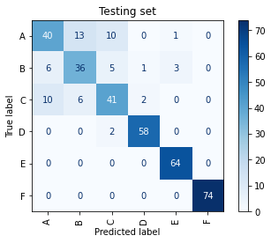
disp = plot_confusion_matrix(xgbc, x_train, y_train, display_labels=class_names, cmap=pyplot.cm.Blues, xticks_rotation='vertical')
pyplot.title('Training set')

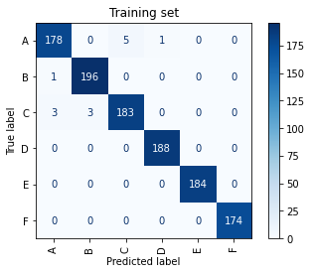
shap_values = shap.TreeExplainer(xgbc).shap_values(x_test)
shap.summary_plot(shap_values, x_test,class_names = class_names, plot_type='bar')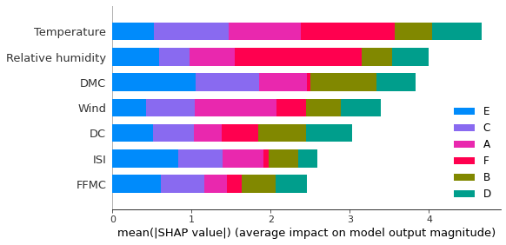

shap.summary_plot(shap_values[0], x_test, class_names=class_names,show=False)
pyplot.gcf().axes[-1].set_box_aspect(50)
pyplot.gcf().axes[-1].set_aspect(100)
pyplot.gcf().axes[-1].set_box_aspect(100)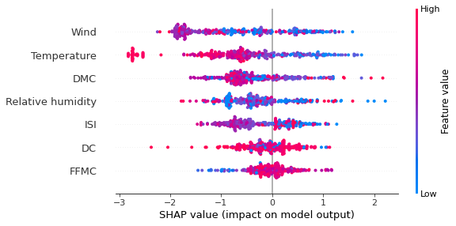
shap.summary_plot(shap_values[1], x_test, class_names=class_names,show=False)
pyplot.gcf().axes[-1].set_box_aspect(50)
pyplot.gcf().axes[-1].set_aspect(100)
pyplot.gcf().axes[-1].set_box_aspect(100)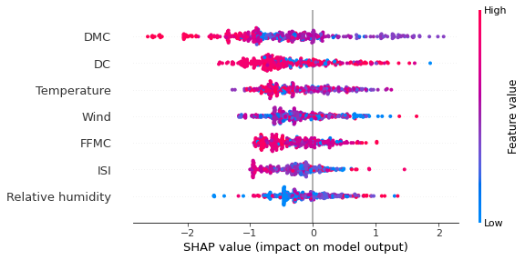

shap.summary_plot(shap_values[2], x_test, class_names=class_names,show=False)
pyplot.gcf().axes[-1].set_box_aspect(50)
pyplot.gcf().axes[-1].set_aspect(100)
pyplot.gcf().axes[-1].set_box_aspect(100)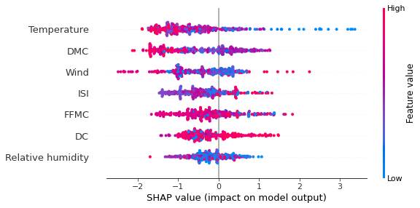
shap.summary_plot(shap_values[3], x_test, class_names=class_names,show=False)
pyplot.gcf().axes[-1].set_box_aspect(50)
pyplot.gcf().axes[-1].set_aspect(100)
pyplot.gcf().axes[-1].set_box_aspect(100)
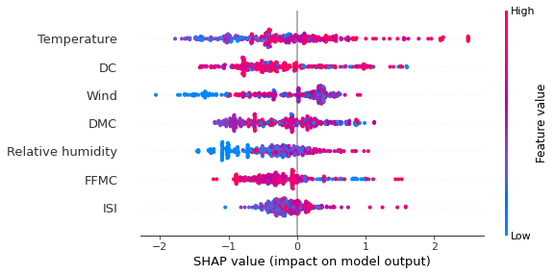
shap.summary_plot(shap_values[4], x_test, class_names=class_names,show=False)
pyplot.gcf().axes[-1].set_box_aspect(50)
pyplot.gcf().axes[-1].set_aspect(100)
pyplot.gcf().axes[-1].set_box_aspect(100)
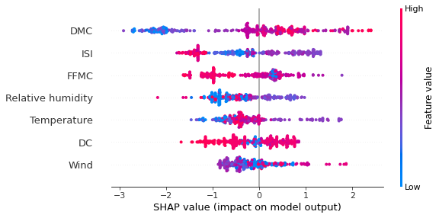
shap.summary_plot(shap_values[5], x_test, class_names=class_names,show=False)
pyplot.gcf().axes[-1].set_box_aspect(50)
pyplot.gcf().axes[-1].set_aspect(100)
pyplot.gcf().axes[-1].set_box_aspect(100)